LAB 6 – Raja Aadhithan
Design – Sequence Detector:
Wave:
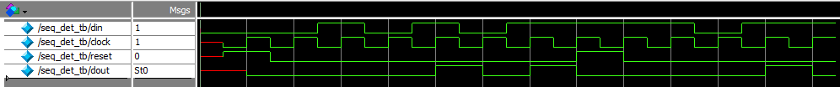
Output:
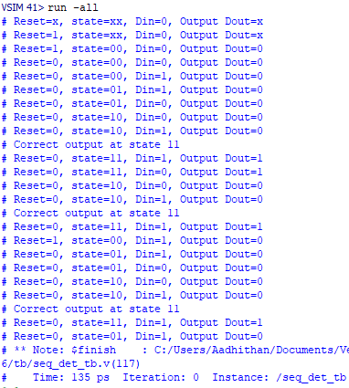

RTL:
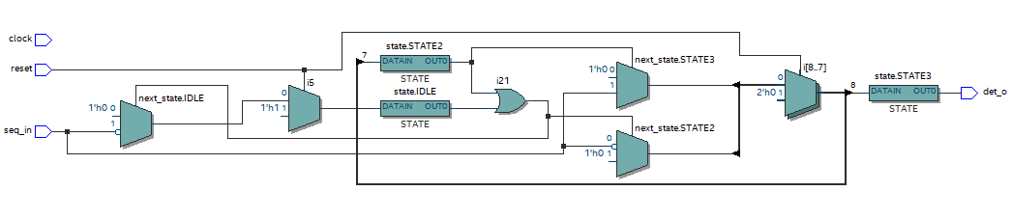
Design : Vending machine:
Wave:
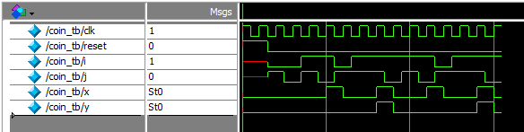
Output:
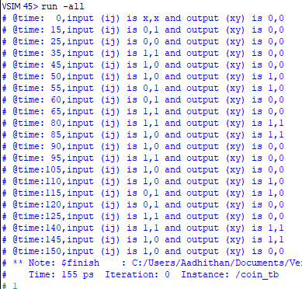
RTL:
